Connect 4 Project Documentation:

* Connect 4 is a 2-player board game which most commonly is a rectangular 6\*7 grid where each player can win by connecting 4 cells of the same color horizontally, vertically, or diagonally.
* The algorithm we used in this implementation was the minimax algorithm in which each player tries to maximize his chances of winning by minimizing the chances of his opponent winning.
* In this implementation, one human player plays against AI.
* When it’s the AI’s turn, the minimax algorithm explores all possible paths it can go in and chooses the best option in this step which also is the worst option for the opposing player.
* The following image represents a simplified 3\*3 version of the exploration of all possibilities:

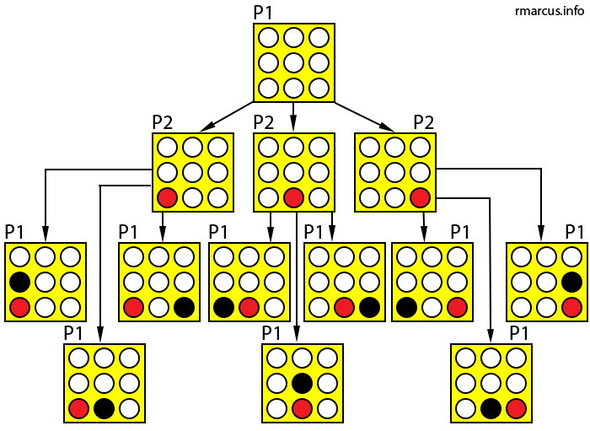

* For example, in the third level, the minimax algorithm explores the tree to get the minimum value recursively so that it chooses the worst option for the player.
* As you might imagine, the complexity of such an implementation is massive so, it needs some sort of optimization; Alpha-beta pruning.
* Alpha-beta pruning is an optimization where the minimax algorithm doesn’t have to explore all possibilities of a certain choice because I already have a smaller value from another choice.